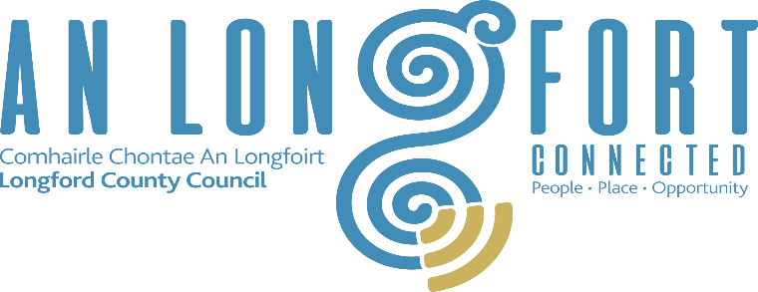

Longford County Council
Aras an Chontae, Great Water Street, Longford.
Tel: (043) 334 3300

Request for Tender (RFT)

E COMMERCE BUSINESS DEVELOPMENT, BUSINESS COACHING, MENTORNG AND EVALUATING SERVICES for the DEVELOP YOUR ON-LINE BUSINESS PROGRAMME

Procedure | OPEN
LCC Reference: | Develop your On-Line Business
Issue Date | 01/02/2022
Closing Date for Queries | 10/02/2022 at 12:00 Noon
Email for Queries | mnevin@longfordcoco.ie
Closing Date / Time for receipt of Tenders | 18/02/2022 at 5:00 pm
Instructions for Return of Tenders: | Completed tender documents to be submitted via email (must be submitted in a SINGLE document, preferably in PDF format or MSWord).

Background

The Local Enterprise Offices (LEOs) are statutory agencies established under the Government’s Action Plan for Jobs. Their primary objective is the promotion of entrepreneurship and the provision of assistance towards the development and growth of enterprises at local level. The LEOs operate under the auspices of the Department of Jobs Enterprise & Innovation. The Boards are funded by the Irish Government and the European Union.

Longford LEO would like to deliver a programme to build on the success of the Trading on-line Voucher Scheme. The programme will assist a percentage of TOV recipients to capitalise on the potential for their on-line platform to deliver more customers, sales and ultimately profits. It will help to ensure that their on-line presence is sustainable and supports the businesses overall ambition for growth.

The programme will involve a mix of individual mentoring and the introduction of measurement systems that allow progress to be tracked and evaluated.

Objectives
- Better integration of on-line sales platform into overall business operations
- Increase in on-line sales volume over the course of the programme
- Better understanding of effective marketing for on-line businesses and development of a live marketing strategy
- Potential to reach into international markets explored
- Develop a system to allow comparison between on-line and off-line sales, to ensure appropriate response times and to assist in improving conversion rates.
- Determine training needs of staff involved and map out a training support plan. Working with the Longford LEO office coordinate group training specific to the needs of the participating companies.

Invitation to Tender

This is an invitation to tender for E-Commerce business development, business coaching, mentoring and evaluation of some On-Line Businesses for the Local Enterprise Office, Longford.

Scope of the Tender

E-Commerce Business Development, Business Coaching, and Evaluation

1.1 E-COMMERCE PROGRAMME OBJECTIVES
- Work with between 10 and 15 companies (TOV recipients) to capitalise on the potential for their on-line platform to deliver more customers, sales and ultimately profits.
- Work to ensure that their on-line presence is sustainable and supports the businesses overall ambition for growth.
1.2 BUSINESS DEVELOPMENT REQUIREMENTS
- Base intervention on an initial on-line meeting held to assess needs and set targets for improvement
- Complete an individual profile for each business with current site analytics along with any other relevant baseline data.
- Develop a simple cost-effective marketing plan.
- Help the businesses improve conversion rates for online queries.
- Identify potential to develop international markets.

1.3 BUSINESS COACHING REQUIREMENTS:
- One to one advice/guidance to each business helping them to better integrate their on-line platform with their core business operations.
- Address business issues that may arise around the further development of their online presence. Topics that have presented before have included – advice/guidance on accounting systems, GDPR, Trading Regulations.
- Determine training needs of staff involved and map out a training support plan. Advise the Longford LEO office on group training specific to the needs of the participating companies.
- Hold 2 one-to-one mentoring sessions (of up to 3 hours duration per session) for each participating company as well as the initial assessment meeting (3 hours)

1.4 EVALUATION REQUIREMENTS:

- Client Report for each of the participating business outlining the following:
- Comparison of base line report figures and current statistics, on-line reach, conversion rates etc.
- Identification and development of a plan for additional investment (if needed) ensuring the platform stays relevant and continues to deliver results.
- Develop a system to measure on-line reach, conversion rates and repeat sales
- Identification of further investment needed to ensure platform continues to deliver expected results
- Measurement of progress from month 1 to 6

Timeline:
The E Commerce project will begin from 20th March and finish up on 20th September 2022.

Tenders will be assessed using the following criteria:
- Ecommerce Experience (35%)
- Business Development and Coaching (35%)
- Price (30%)

The contracting entity will not be responsible for any costs, charges or expenses incurred by candidates or tenderers relating to this contract award procedure.

The lowest or any tender will not necessarily be accepted, and the successful tenderer will be required to produce a current Tax Clearance Certificate before the contract is awarded.

Key Guidelines:
- Submission date for tender is 18th February 2022 at 5pm.
- State clearly total fee excluding VAT.
- Please submit a proposal including the following:
- Information on the company including previous experience in this or relevant sectors
- Profile of the individual/s within the company who would be assigned to this task and who would be delivering the service
- Approach to achieving the objectives outlined
- Details of proposed activities including timelines
- Essential requirements (eligibility to tender): Current tax clearance certificate.
- Withholding tax may apply.

Response Instructions:
Quotations must be submitted, by email, on or before 5pm on 18th February 2022 to mnevin@leo.longfordcoco.ie

End of Document

